***sanjaykumar ss***

***727721euit140***

**Question 1:**

**package** com.test.demo;

**import** org.openqa.selenium.By;

**import** org.openqa.selenium.WebDriver;

**import** org.openqa.selenium.WebElement;

**import** org.openqa.selenium.chrome.ChromeDriver;

**import** org.openqa.selenium.chrome.ChromeOptions;

**import** io.github.bonigarcia.wdm.WebDriverManager;

**public** **class** Q1 {

**public** **static** **void** main(String[] args) **throws** InterruptedException {

ChromeOptions co=**new** ChromeOptions();

co.addArguments ("--remote-allow-origins=*");

WebDriverManager.*chromedriver*().setup ();

WebDriver driver=**new** ChromeDriver(co);

driver.get ("https://www.amazon.in/Spigen-Urban-Fabric-Compatible-MacBook/dp/B09R2KCXD2/?_encoding=UTF8&pd_rd_w=hN3t9&content-id=amzn1.sym.e0e8ce89-ede3-4c51-b6ad-44989efc8536&pf_rd_p=e0e8ce89-ede3-4c51-b6ad-44989efc8536&pf_rd_r=10MH3SN3ES208H0RRNSQ&pd_rd_wg=wPWJi&pd_rd_r=13f23fa2-e355-40ad-a989-abace7275caf&ref_=pd_gw_ci_mcx_mr_hp_d");

driver.manage().window().maximize() ;

String currentTitle=driver.getTitle();

System.***out***.println(currentTitle);

String expectedTitle="Spigen Urban Fit Fabric Case Cover Compatible with MacBook Pro 14 inch (2021) - Black - Buy Spigen Urban Fit Fabric Case Cover Compatible with MacBook Pro 14 inch (2021) - Black Online at Low Price in India - Amazon.in";

**if**(currentTitle.equals(expectedTitle)) {

System.***out***.println("Title Matched");

}

**else** {

System.***out***.println("Title not Matched");

}

driver.findElement(By.*xpath*("//*[@id=\"add-to-cart-button\"]")).click();

driver.findElement(By.*xpath*("//*[@id=\"nav-cart\"]")).click();

driver.findElement(By.*xpath*("//*[@id=\"a-autoid-0-announce\"]")).click();

driver.findElement(By.*xpath*("//*[@id=\"quantity_4\"]")).click();

driver.findElement(By.*xpath*("//*[@id=\"sc-buy-box-ptc-button\"]/span/input")).click();

WebElement txtBoxl=driver.findElement(By.*xpath*("//*[@id=\"ap_email\"]"));

txtBoxl.sendKeys("sanjaykumaar916@gmail.com");

driver.findElement(By.*xpath*("//*[@id=\"continue\"]")).click();

WebElement txtBox2=driver.findElement(By.*xpath*("//*[@id=\"ap_password\"]"));

txtBox2.sendKeys("Sanjay6979@");

driver.findElement(By.*xpath*("//*[@id=\"signInSubmit\"]")).click();

}

}

**Output:**

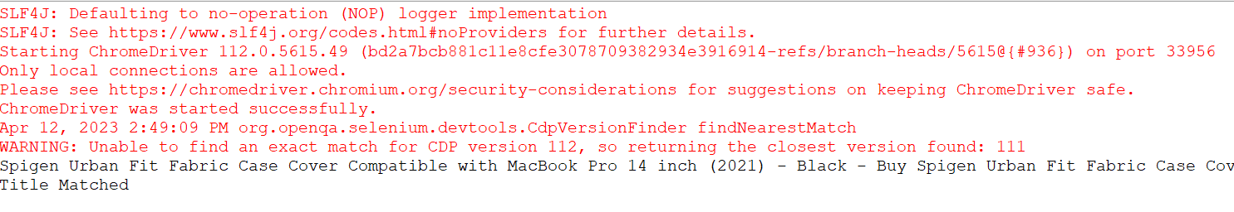

**Question 2:**

**package** com.test.demo;

**import** org.openqa.selenium.By;

**import** org.openqa.selenium.WebDriver;

**import** org.openqa.selenium.WebElement;

**import** org.openqa.selenium.chrome.ChromeDriver;

**import** org.openqa.selenium.chrome.ChromeOptions;

**import** io.github.bonigarcia.wdm.WebDriverManager;

**public** **class** Q2 {

**public** **static** **void** main(String[] args) {

// **TODO** Auto-generated method stub

ChromeOptions co=**new** ChromeOptions();

co.addArguments ("--remote-allow-origins=*");

WebDriverManager.*chromedriver*().setup ();

WebDriver driver=**new** ChromeDriver(co);

driver.get ("https://www.amazon.in/");

driver.manage().window().maximize() ;

String currentTitle=driver.getTitle();

System.***out***.println(currentTitle);

String expectedTitle="Online Shopping site in India: Shop Online for Mobiles, Books, Watches, Shoes and More - Amazon.in";

**if**(currentTitle.equals(expectedTitle)) {

System.***out***.println("Title Matched");

}

**else** {

System.***out***.println("Title not Matched");

}

WebElement txtBoxl=driver.findElement(By.*xpath*("//*[@id=\"twotabsearchtextbox\"]"));

txtBoxl.sendKeys("macbook");

driver.findElement(By.*xpath*("//*[@id=\"nav-search-submit-button\"]")).click();

//displaying 5 products

String txt1=driver.findElement(By.*xpath*("//*[@id=\"search\"]/div[1]/div[1]/div/span[1]/div[1]/div[3]/div/div/div/div/div/div/div/div[2]/div/div/div[1]/h2/a/span")).getText();

System.***out***.println(txt1);

String txt2=driver.findElement(By.*xpath*("//*[@id=\"search\"]/div[1]/div[1]/div/span[1]/div[1]/div[4]/div/div/div/div/div/div/div/div[2]/div/div/div[1]/h2/a/span")).getText();

System.***out***.println(txt2);

String txt3=driver.findElement(By.*xpath*("//*[@id=\"search\"]/div[1]/div[1]/div/span[1]/div[1]/div[5]/div/div/div/div/div/div[2]/div/div/div[1]/h2/a/span")).getText();

System.***out***.println(txt3);

String txt4=driver.findElement(By.*xpath*("//*[@id=\"search\"]/div[1]/div[1]/div/span[1]/div[1]/div[6]/div/div/div/div/div/div[2]/div/div/div[1]/h2/a/span")).getText();

System.***out***.println(txt4);

String txt5=driver.findElement(By.*xpath*("//*[@id=\"search\"]/div[1]/div[1]/div/span[1]/div[1]/div[7]/div/div/div/div/div/div[2]/div/div/div[1]/h2/a/span")).getText();

System.***out***.println(txt5);

//filter

driver.findElement(By.*xpath*("//*[@id=\"p_36/7252032031\"]/span/a/span")).click();

driver.findElement(By.*xpath*("//*[@id=\"p_n_pattern_browse-bin/1464446031\"]/span/a/span")).click();

}

}

**Output:**

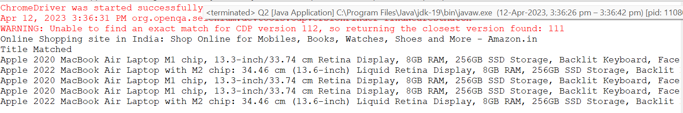

**Question 3:**

**package** com.test.demo;

**import** org.openqa.selenium.By;

**import** org.openqa.selenium.WebDriver;

**import** org.openqa.selenium.WebElement;

**import** org.openqa.selenium.chrome.ChromeDriver;

**import** org.openqa.selenium.chrome.ChromeOptions;

**import** io.github.bonigarcia.wdm.WebDriverManager;

**public** **class** Q3 {

**public** **static** **void** main(String[] args) **throws** InterruptedException {

ChromeOptions co=**new** ChromeOptions();

co.addArguments("--remote-allow-origins=*");

WebDriverManager.*chromedriver*().setup();

WebDriver driver=**new** ChromeDriver();

driver.get("https://www.amazon.in/ap/signin?openid.pape.max_auth_age=0&openid.return_to=https%3A%2F%2Fwww.amazon.in%2F%3Fref_%3Dnav_ya_signin&openid.identity=http%3A%2F%2Fspecs.openid.net%2Fauth%2F2.0%2Fidentifier_select&openid.assoc_handle=inflex&openid.mode=checkid_setup&openid.claimed_id=http%3A%2F%2Fspecs.openid.net%2Fauth%2F2.0%2Fidentifier_select&openid.ns=http%3A%2F%2Fspecs.openid.net%2Fauth%2F2.0&");

driver.findElement(By.*xpath*("//*[@id=\"ap_email\"]")).click();

driver.findElement(By.*xpath*("//*[@id=\"ap_email\"]")).sendKeys("sanjaykumaar916@gmail.com");

driver.findElement(By.*xpath*("//*[@id=\"continue\"]")).click();

driver.findElement(By.*xpath*("//*[@id=\"ap_password\"]")).click();

driver.findElement(By.*xpath*("//*[@id=\"ap_password\"]")).sendKeys("Sanjay6979@");

driver.findElement(By.*xpath*("//*[@id=\"signInSubmit\"]")).click();

Thread.*sleep*(3000);

driver.findElement(By.*xpath*("//*[@id=\"nav-link-accountList\"]")).click();

WebElement acc=driver.findElement(By.*xpath*("//*[@id=\"a-page\"]/div[2]/div/div[1]/h1"));

String actual=acc.getText();

String expected="Your Account";

**if**(actual.equals(expected)) {

System.***out***.println("Your Account page is displayed");

}

driver.findElement(By.*xpath*("//*[@id=\"a-page\"]/div[2]/div/div[2]/div[1]/a/div")).click();

WebElement ord=driver.findElement(By.*xpath*("//*[@id=\"a-page\"]/section/div[1]/div[2]/div[1]/h1"));

String act=ord.getText();

String exp="Your Orders";

**if**(act.equals(exp)) {

System.***out***.println("Your Order page is displayed");

}

String act1=ord.getText();

String exp1="Your orders";

**if**(act1.equals(exp1)) {

System.***out***.println("User is able to track package");

}

System.***out***.println("User is able to view their products");

}

}

**Output:**

